**WOODSTORE-ECOMMERCE-FURNITURE-WEB-APPLICATION**

**MYSQL DATABASE DETAILS-**

* TABLES CREATED:
* User Details Table-

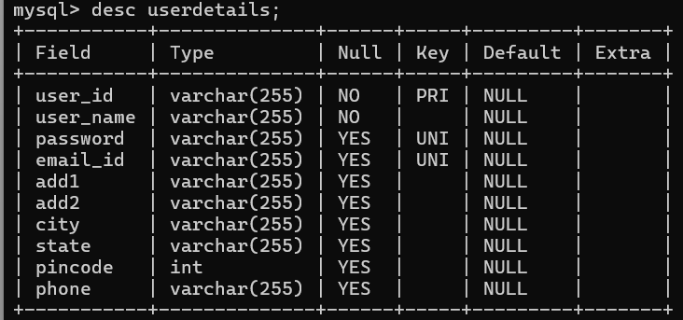

* Products Table-

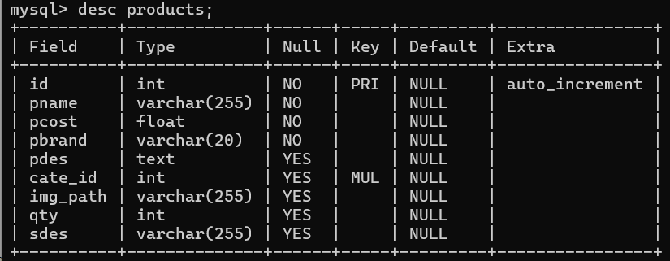

* Product Categories Table-

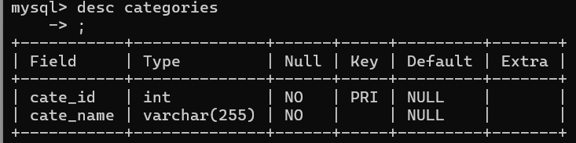

* Cart Table-

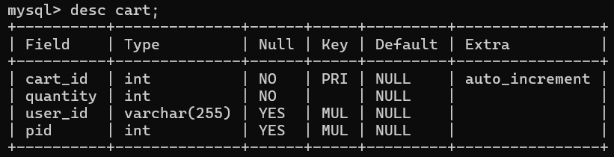

* 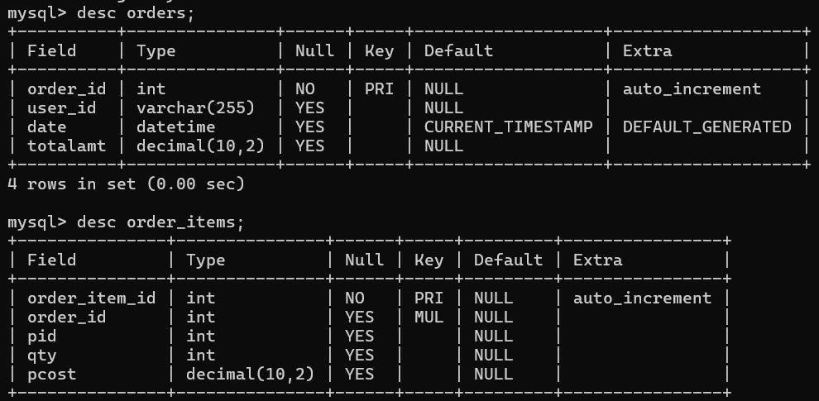Orders and Order_items Table-
* 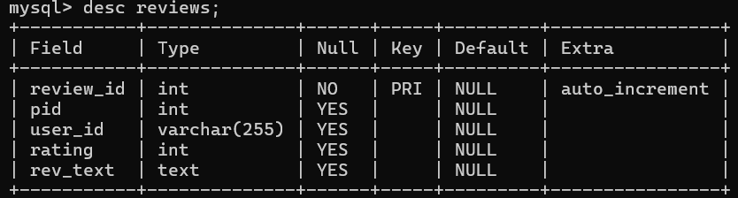Reviews Table-
* PROCEDURES CREATED:
* 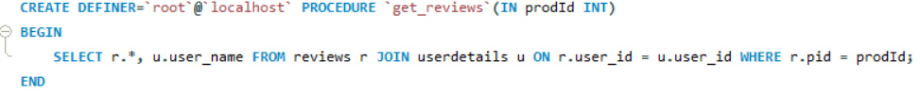get_reviews-
* submit_reviews-



* 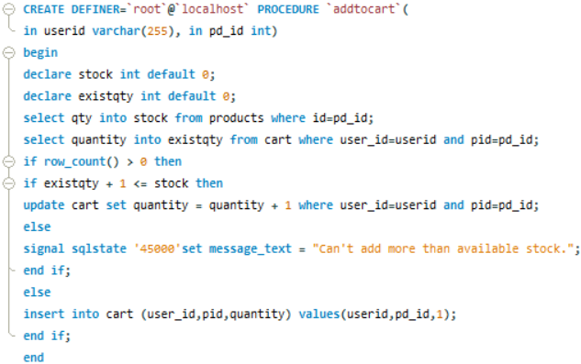addtocart-
* admin_add-

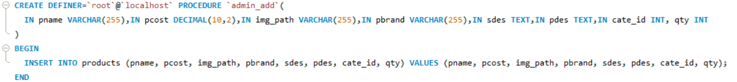

* get_brand- (similarly for get_category)

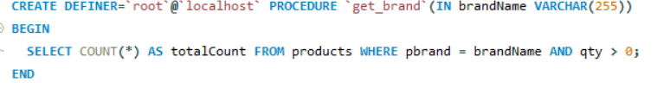

* 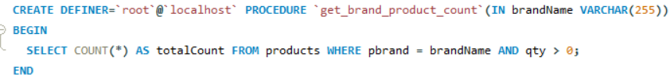get_brand_page- (similarly for get_category_page)
* 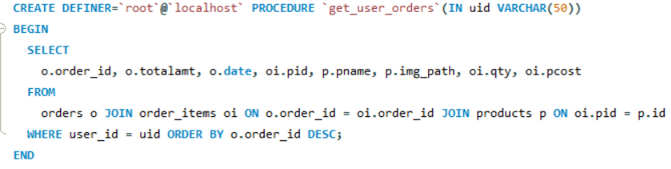get_user_orders-
* 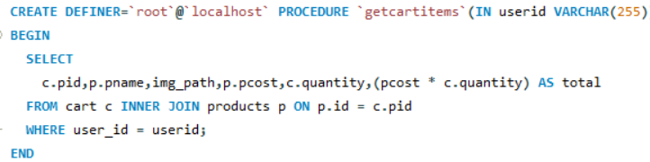get_cart_items-
* get_prod_details-
* get_products-
* getreivew_rating-
* getsimilar_products-